**VEHICLE EMISSION MOINTORING AND CONTROL USING IOT**

Bhushan Chaudhari1* , Harshit Arun Gujarathi2, Manish Shankarlal Makhija3  Ramandeepkaur Banvat4 , Lokesh Dipak Patil5

*1 (Associate professor, Dept of Information Technology SVKM’s IOT , Dhule India,* *chaudharibs@gmail.com*)*

*2345 (BTECH IV year, Dept of Information Technology SVKM’s IOT , Dhule India,harshitguju20@gmail.com)*

**Abstract**

**Vehicle emissions monitoring and control using the Internet of Things is a promising approach to reduce air pollution and improve public health. IoT-based vehicle emissions monitoring systems can collect real-time data on the levels of pollutants emitted by vehicles, such as carbon monoxide, Hydrocarbon, and Carbon dioxide. This data can be used to identify vehicles with high emissions, to notify vehicle owners of potential problems, and to enforce emissions standards. IOT- based vehicle emissions control systems can go even further, using the collected data to automatically adjust vehicle settings or even to take vehicles out of service if their emissions exceed certain levels. This can help ensure that all vehicles operate as cleanly as possible. The sensor data is then transmitted to an ESP32 micro- controller development board which analyzes the data and takes appropriate action. The sensor data is then transmitted to a microcontroller, which analyzes the data and takes appropriate action. IoT-based vehicle emissions monitoring and control systems have a number of potential benefits. They can result in reducing air pollution and improve public health, increase fuel efficiency and save drivers money, Extend the life of vehicles and reducing greenhouse gas emissions and mitigate climate change.**

*Keywords —vehicles, CO, HC, C02, ESP32*

1. Introduction

The Internet of Things uses the Internet to create real-time connections between components and the Internet, enabling emissions monitoring and control systems to be developed in a more efficient and effective approach than is currently available. The ESP32 development microcontroller, with its Wi-Fi and Bluetooth modules, is an extremely flexible and powerful microcontroller that has the potential to be used to design IOT devices. It is equipped with a Wi-Fi and Bluetooth module, enabling it to connect to the internet and other devices.

In India, the Pollution Under Control (PUC) system is a mandated vehicle emission testing initiative aimed at lowering vehicle-related air pollution. Since its initial introduction in Delhi in 1991, the program has been carried out in all of the nation's main cities. It is critical that we efficiently monitor and control vehicle emissions to reduce these emissions, which are one of the most significant sources of air pollution and can have major consequences on human health and the environment. All cars must submit to periodic emissions testing at PUC centers that have been authorized under the PUC system. The vehicle's emissions of different pollutants, including nitrogen oxides, hydrocarbons, and carbon monoxide, are measured during the tests. India's air pollution has been decreased thanks in large part to the PUC system. But the system's shortcomings and lack of openness have also drawn criticism. The prevalence of phony PUC certificates is one of the main obstacles. By paying PUC center employees, or by having their cars evaluated without being examined, many car owners are able to get PUC certificates. This compromises the system's efficacy and permits the continued use of cars that cause pollution on the highways. A further difficulty is the absence of national standards. Every state has its own emission standards and PUC testing protocols. Car owners may find it challenging to adhere to the PUC system as a result, particularly if they travel between states frequently.

The PUC system is nevertheless a valuable instrument for lowering air pollution in India in spite of these difficulties. The government has implemented several initiatives to increase the system's efficacy, including the creation of online PUC centers and increased transparency in the testing procedure. The PUC system has been the subject of several reform suggestions in recent years. Creating a centralized database with all of the PUC test results is one suggestion. This will facilitate the tracking of vehicles that are either phony or have not gotten a PUC certificate. Testing car emissions while they are on the road using remote sensing technologies is another suggestion. This would make it easier to find vehicles that emit pollutants and can avoid PUC testing.

The Internet of Things uses the Internet to create real-time connections between components and the Internet, enabling emissions monitoring and control systems to be developed in a more efficient and effective approach than is currently available In general, India's PUC system is a well-meaning initiative with the potential to significantly lower air pollution. The system is not without its difficulties, though. To fully realize the potential of the system, additional actions by the government are required to enhance its efficacy and openness It shows how to set up an IoT-based automotive emissions monitoring and control system using the ESP32 development micro-controller via sensors from the The ESP32 microcontroller can be connected to the gas sensors that have been installed on the car. The ESP32 microcontroller calculates a car’s emissions using a combination of gas sensors and a microprocessor to calculate the ppm emissions. To send the emission data from the vehicle to a cloud server, the ESP32 microcontroller uses WiFi technology. Real-time vehicle emission levels can be monitored via a web- based program or a mobile app. Suppose the emissions from your vehicle exceed a certain point in time. In that case, the ESP32 microcontroller is capable of triggering a control device, such as a fan or a valve, to reduce the pollutants.

Figure 1 Smoke emitted by different types of vehicles

1. Literature Survey

A thorough review of the literature, it demonstrates the increasing amount of research addressing the pressing need for creative solutions to deal with the problems related to public health and the environment that are becoming more and more pressing. Analyzing and tracking vehicle emissions is essential for tackling environmental issues and guaranteeing environmentally friendly transportation methods. Vehicle emissions are having a growing impact on air quality and climate change, thus advanced technologies are being used to measure and evaluate the toxins that vehicles release. Certain surveys offer creative methods for tracking and analyzing vehicle emissions. offers an Internet of Things (IoT)-based smoke detection system that uses machine learning to achieve high accuracy by combining air temperature and humidity [1]. By seamlessly integrating technologies for the real-time measurement of vehicle emissions, this system represents a substantial advancement in environmental monitoring. There are numerous surveys on the current systems for detecting gas leaks and fires. Smoke detection is crucial in fire safety since it provides early warnings and allows for quick response actions. suggest a computation technique to forecast smoke and heat detector behavior. Their research, which was published in Fire Science and Technology, helps to build efficient fire detection systems by identifying the variables that affect detector response [14]. Which present a framework for IoT-based fire detection and mitigation. Their research, which highlights the significance of IoT in boosting safety measures, outlines a holistic approach to fire detection and was published in the International Journal of Pure and Applied Mathematics [15].

An IoT-based intelligent modeling of a smart home environment for safety and fire prevention is presented This research, which was published in the Journal of Sensors and Actuator Networks, focuses on how IoT technologies might be integrated to build intelligent systems that improve home safety, particularly in the area of fire prevention [20]. Scholars have investigated the design and development of novel smoke detection systems intended for use in moving vehicles. Several studies emphasize how crucial it is for cars to have early and accurate smoke detection because of the potentially life-saving consequences describes the development and testing of automated smoke monitoring sensors in cars in the IEEE Sensors Journal, making progress toward pollution control for automobiles [2].

With the goal of improving vehicle safety, lowering air pollution and for improved data collecting and gas emission monitoring, there are numerous surveys on digital communication, networks, and security. illuminated the wide range of possible applications within the sensor network industry with their thorough investigation of wireless sensor network (WSN) applications. The research probably explores the various domains in which WSNs are essential. Because they enable the real- time collection of data on variables like temperature, humidity, and pollution levels, WSNs have become essential in environmental monitoring [10]. The use of wireless sensor networks for environmental monitoring in support of sustainable mobility is investigated In order to promote sustainable mobility initiatives, their study investigates how sensor networks might be used for extensive data gathering and analysis [11].

The primary objective is the employment of sensors mounted on municipal buses for real-time monitoring of air quality. The deployment of sensors on buses as mobile monitoring units is covered in the research, which was published in Digital Communications and Networks. This approach offers important insights into the dynamics of urban air quality [12]. Using a wireless sensor network and ZigBee technology, describe an intelligent smoke alarm system. Their work on the integration of wireless communication for effective smoke detection was published in Wireless Communications and Mobile Computing [16].

In the context of the Internet of Things (IoT), networks play a critical role as the fundamental infrastructure that facilitates smooth communication and cooperation amongst objects that are connected. which sensors to use in wireless visual sensor networks in order to improve target localization accuracy. The goal of their work, which was published in IET Wireless Sensor Systems, is to improve localization in visual sensor networks by strategically placing sensors [21]. Offer cooperative cognitive intelligence for the Internet of Vehicles. In an effort to increase overall vehicular communication and safety, the project explores the use of cognitive intelligence to promote collaboration among cars in the Internet of Things [22]. Write in the EURASIP Journal on Wireless Communications and Networking on cognitive radio for vehicular ad hoc networks (CR-VANETs). The study examines methods and difficulties related to the application of cognitive radio in automobile networks [23]. have put forth a decentralized vehicle remote locating and tracking system that is economical and utilizes both mobile networks and the BeiDou navigation satellite system. The research aims to provide a workable and affordable method for vehicle Smoke detection in cars. A sensor-based application for smart cars in the International Journal of Latest Trends in Engineering and Technology. Their research examines how sensors can be used to increase car's intelligence for better functioning & safety [17]. Cities face two challenges at once: the growth in automobile traffic and the resulting rise in air pollution. For smoke detection, assess the best location for sensors in the Yugoslav Journal of Operational Research. Their study advances our knowledge of where to put sensors in smoke detection systems to get the best results [25].

Furthermore, the literature highlights how these Internet of Things-enabled smoke detection systems fit into the larger picture of connected cars and smart transportation, helping to advance the development of clever and safer mobility solutions. Prospective pathways within this field of study are well-positioned to tackle issues concerning system scalability, power efficiency, and smooth integration with current car communication networks. The literature review as a whole shows a determined attempt to use technology to protect drivers and passengers, reflecting a growing understanding of the potential of IoT-based smoke detection systems to improve vehicle safety

1. Methodology

In this system sensors are positioned at a precise distance in order to record and identify the smoke part per million value. The esp 32 Wi-Fi 32 module processes the analog data received from the sensors. It is attached to a laptop or other display device by a micro USB wire.

*3.1 Algorithm for converting analog input into digital Output*

1. Define the analog pins that are attached to the gas sensor s(mq135, mq7, and mq2).
2. Read the MQ-135 sensor’s analog value and save it in the variable mq135Value
3. Read the MQ-7 sensor’s analog value and save it in the variable mq7Value.
4. Read the MQ-2 sensor’s analog value and put it in the variable mq2Value
5. Depending on the sensor specifications and calibration data, you can optionally execute calibration or further data processing on these raw analog values to convert them into useful gas concentration readings
6. Print or use the values as needed (for example, printing to the serial monitor, sending data to a display and sending across a network.
   * 1. *Sensors use*

Table 1 : Sensors Overview

|  |  |
| --- | --- |
| Sensors Name | Detect |
| MQ2 | Hydrocarbon |
| MQ7 | Hydro monoxide |
| MQ135 | Carbon Dioxide |

Table 1 represents following sensors overview used in this research

* + 1. *MQ135 Gas sensor*

The MQ-135 gas sensor is a small, reasonably priced instrument that can identify a wide range of gases, which makes it useful for air quality monitoring applications. This sensor is very good at picking up on a variety of volatile organic chemicals and gasses like carbon dioxide, ammonia, and benzene. The MQ-135 functions based on the idea that resistance varies according to the target gas concentration. Because of its analog output, microcontrollers can be easily interfaced with it. Because of its adaptability, sensitivity, and simplicity of integration, this sensor is widely used for tasks including pollution detection and indoor air quality monitoring in settings where accurate gas sensing is essential. Precise measurement is made possible by its analog output, which produces a voltage according to the measured Gas's concentration. The MQ-135 has a quick reaction time and performs well in a variety of environmental In this research the Ground pin was linked with esp32’s ground the voltage pin to the vcc and the analog pin to pin D35

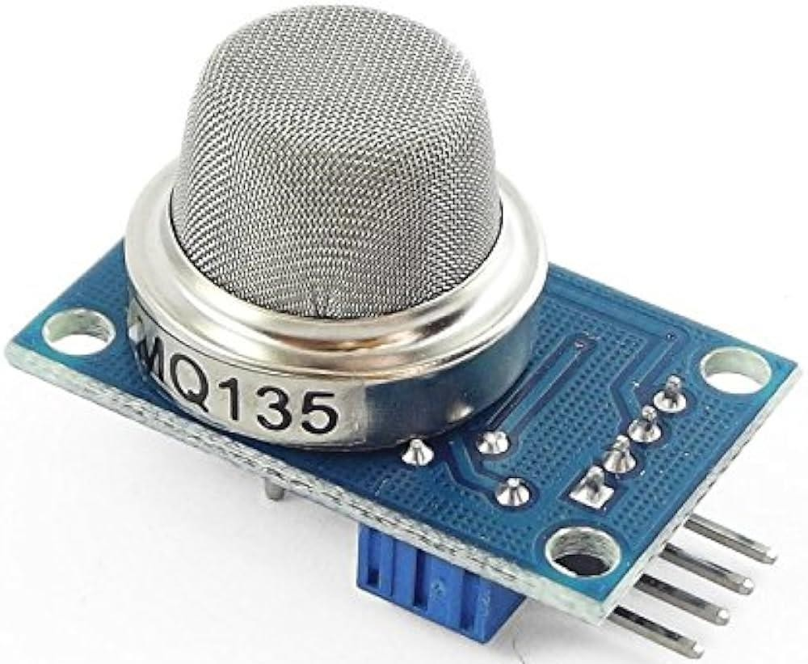

Figure 2 MQ135 Sensor

* + 1. *MQ3 Gas sensor*

The multifunctional MQ-2 gas sensor module is intended to identify different flammable gases and smoke in the atmosphere. It is appropriate for uses like gas leak detection and air quality monitoring due to its sensitivity to gases including methane, propane, carbon monoxide, and smoke. To provide precise measurements, the sensor outputs an analog voltage according to the concentration of the detected gas. Changes in gas concentrations can be swiftly detected by the MQ-2 thanks to its high sensitivity and quick response time. Its cost-effectiveness, small size, and simplicity of integration with microcontrollers make it a popular choice for Internet of Things applications, such those that monitor and regulate automobile emissions. In this Research the ground pin was linked to the esp32's ground, the voltage pin to the vcc, and the analog pin to pin D32.

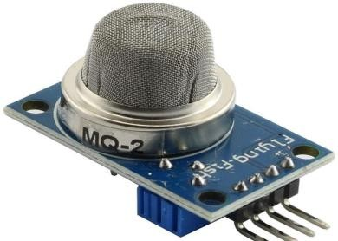

Figure 3. MQ2 Sensor

# MQ7 Gas Sensor

The MQ-7 gas sensor module is well-known for its capacity to identify natural gas and carbon monoxide in the atmosphere. Due to its high sensitivity to various gases, this little sensor offers a dependable way to check the quality of the air indoors and find possible gas leaks. The MQ-7 enables accurate measurements with an analog output that changes proportionately to the CO or natural gas content. It works well for real-time monitoring applications due to its quick reaction time and great sensitivity. The sensor may be easily integrated into Internet of Things systems, especially those that are intended to monitor and regulate automobile emissions, because it is compatible with microcontrollers. The MQ-7 is widely used in a variety of environmental sensing applications because of its low cost, precision, and simplicity of use.In this Research the ground pin was linked to the esp32 ground, the voltage pin to the Vcc, and the analog pin to pin D34.

Figure 4 : MQ135 Sensor

*3.2 Mathematical Modeling*

1. Converting monoxide from g/h to ppm value

*(CO concentration in g/h) / (exhaust gas flow rate in m³/h) * 1,000,000* (1)

The equation 1 describe the CO concentration expressed in grams per hour: This is the amount of CO released in grams per hour. Picture a car shooting out CO like little pieces of confetti; this is the number of confetti pieces (grams) that are released each hour.

The flow rate of exhaust gas in m³/h. This is the cubic meter-per-hour amount of exhaust gas that is released. Consider it as the amount of CO confetti that a bucket can contain in an hour; the larger the bucket, the more confetti it can store. 1000000: This is a conversion factor for parts per million to grams per cubic meter. It's as though there's a magic number that converts our count of confetti into a more manageable "ppm" scale.

**Steps for converting Carbon Monoxide to ppm value**

1. Divide: The exhaust gas flow rate (cubic meters/hour) should be divided by the CO concentration (grams/hour). You can use this to find the CO concentration in grams per cubic meter. To calculate the density of confetti in the bucket, divide the number of pieces (grams) by the size of the bucket (cubic meters).
2. Multiply: Increase the outcome of step 1 by a factor of one million. By doing this, parts per million are created from grams per cubic meter. It's similar to turning the confetti density into a more controllable "ppm" figure by using the magic number
3. Converting Carbon dioxide to ppm value:

*(C02 concentration in mg/km) / (exhaust gas volume per km in m³) * 1,000,000* (2)

The equation 2 describe C02 concentration, expressed in milligrams per kilometer of exhaust gas, is indicated by this value. It might be acquired by the use of a particular tool or measurement method.

Exhaust gas volume per km, expressed in m³: This indicates how much exhaust gas the car produces every kilometer. It may be computed using engine parameters or obtained from technical specifications.

1,000,000 is the conversion factor used to change cubic meters into cubic centimeters and milligrams into parts per million (ppm).

**Steps for converting Carbon dioxide to ppm value**

1. Divide the volume of exhaust gas per km (m³) by the C02 concentration (mg/km). This provides you with the C02 concentration in mg/m3, or milligrams per cubic meter.
2. Multiply the outcome by one million. With this, mg/m³ is converted to ppm by volume
3. Converting Hydro carbon (ppmV) from % saturation

*(% saturation * saturated of Hydrocarbon) / 10,000* (3)

The Equation 3 Describe % saturation: The percentage of Hydro carbon present in the exhaust gas as a percentage of the maximum quantity achievable at the specified temperature is expressed here. It relates to the relative humidity of the exhaust gas. Saturated Hydrocarbon pressure at the temperature that was measured: The maximum amount of water vapor that can exist in a closed space at a given temperature is indicated by this physical constant. 10,000: This is the conversion factor used to convert parts per million to percent saturation.

**Steps for converting Hydrocarbon to ppm value**

1. Multiply the percentage saturation by the saturated Hydrocarbon pressure at the temperature that was recorded. This provides you with the water vapor partial pressure in Pascals (Pa) of the exhaust gas.
2. Divide This converts Pa to ppmV. Pa to ppmV. The partial pressure of Hydrocarbon is divided by 10,000. Pa is now equal to ppm.
   1. *Architecture*

A portable instrument for determining the amount of vehicle smoke in parts per million (ppm) is depicted in the diagram you submitted. There are four sensors on the device: a smoke unit sensor, MQ2, MQ7, and MQ135 which measures the smoke and gas emitted by the vehicles

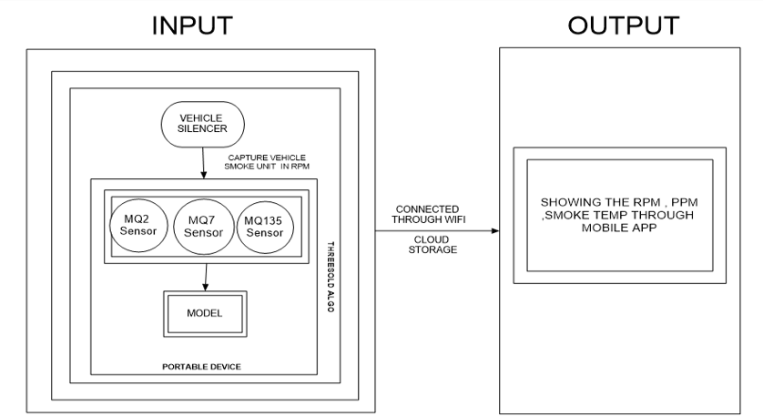

Figure 5 Architecture of model

A microcontroller receives the sensor data and processes it before displaying the ppm value on

a touchscreen displays.

Gas sensors, a microprocessor, and data processing components are all integrated into the system architecture for a gas monitoring project. Gas concentrations are detected and measured using gas sensors, such as those for hydrocarbons (HC), carbon dioxide (CO2), and carbon monoxide (CO). The raw data from these sensors is supplied into a microcontroller, which is in charge of signal conditioning and data collection. Sensor for vehicle smoke unit: This sensor finds smoke in a moving vehicle. The MQ2, MQ7, and MQ135 sensors are utilized for determining the levels of various gases in the atmosphere

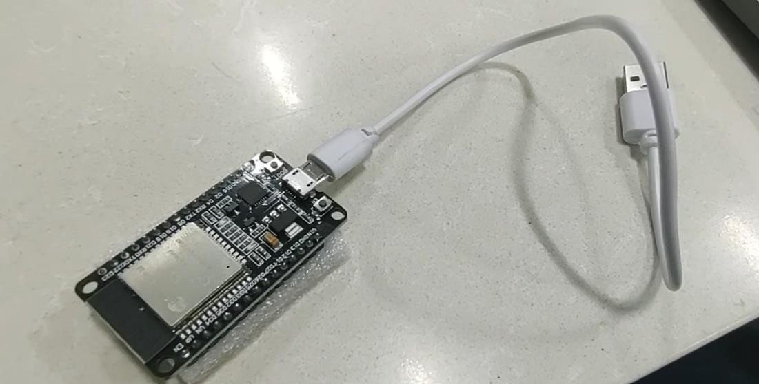Microcontroller: The microcontroller determines the vehicle smoke percentage (ppm) by processing sensor data. Device: The ppm value of the car smoke is shown on the touchscreen display Wi-Fi: The gadget can send the ppm value to a distant application thanks to the Wi-Fi module.

Figure 6 ESP 32 Dev Board with USB micro-B cable

The ESP32 is a flexible microcontroller that comes with built-in Bluetooth and Wi-Fi, making it a great option for Internet of Things-based vehicle emission control and monitoring. Its low-power modes add to its longer operational life, which is important for in-vehicle applications, and its dual-core processor guarantees efficient data processing. The ESP32's set of GPIO pins, which includes analog inputs, makes it easy to interface with different sensors for environmental monitoring

* 1. *Use case*

Use case is the overall description diagram of the scenario of the project. In the figure 7 It depicts the methodology applied in the system analysis to identify and organize the system of our vehicle emission monitoring and control using IOT. The Vehicle Emission Monitoring System with Internet of Things technology offers a real-time monitoring and analysis system that addresses environmental concerns associated with vehicle emissions. The major actors of this project are vehicle and end-user which performs the operations like sensor and device idle state, fetch and show the ppm values

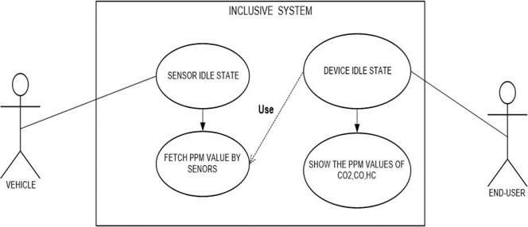

Figure 7. Use case Diagram

The principal components are:

1. Sensors: The sensors identify additional gases and smoke in the exhaust of the car. MQ2, MQ7, and MQ135 are common sensors found in car smoke detection systems.
2. Microcontroller: The system's brain is the microcontroller. It gathers information from the sensors, analyzes it, and uses that information to make decisions.
3. Display: The display provides the user with the outcomes of the smoke detection procedure.
4. Interface for communication: The interface for communication enables the system to speak with other gadgets, like a computer or smartphone.

Here's how the system operates:

The sensors identify additional gases and smoke in the exhaust of the car. The microcontroller receives data from the sensors. The concentration of smoke and other gases is computed by the microcontroller after processing the data. The microcontroller checks to see if the smoke content has risen above a predetermined level. The microcontroller triggers the alarm if the amount of smoke exceeds the predetermined threshold. The user is made aware of the existence of smoke in the car's exhaust by the alarm. Additionally, over time, the system can be used to gather information about the vehicle's emissions. This information can be used to track the success of pollution reduction measures and identify cars that areproducing excessive amounts of smoke.

* + 1. *Sequence Diagram*

The system for measuring and identifying car smoke is simplified in the It consists of multiple parts that cooperate to monitor and sound an alert for elevated smoke levels

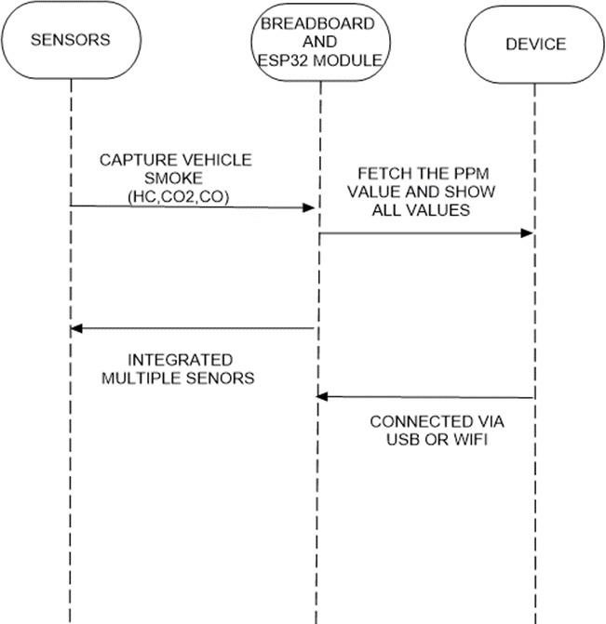

Figure 8 Sequence Diagram

The diagram shows a useful method for detecting and monitoring vehicle smoke emissions, which promotes environmental safety and well-informed decision-making.

Multiple Sensors: The MQ2, MQ7, and MQ135 major sensors are used by the system. Certain gases that are frequently found in car smoke are detected by these sensors:

1. MQ2: Finds gases that can catch fire, such as hydrogen, propane, and methane.
2. MQ7: Monitors the concentrations of carbon monoxide (CO), a major part of automotive exhaust.
3. MQ135: Evaluates a range of gases that are involved in air pollution, including carbon dioxide (CO2).

The system's primary processing unit is made up of the ESP32 module and breadboard. A breadboard connects the sensors and microprocessor to provide a platform for prototyping. An integrated

microcontroller known as the ESP32 Module collects, processes, and exchanges data with other devices.

Capture Car Smoke: The breadboard-connected smoke unit sensor senses the presence of car smoke.

Obtain PPM Value: After receiving information from the sensors, the microcontroller determines each gas's concentration in parts per million (ppm)Show All Values: A display device receives the ppm values from the microcontroller and displays the current smoke component levels.

USB or Wi-Fi Connection: The ESP32 module allows data transmission to other devices over USB or Wi-Fi, facilitating integration with distant systems or real-time monitor.

1. **Result and Discussion**

The following are the real-time results based on the experimental model

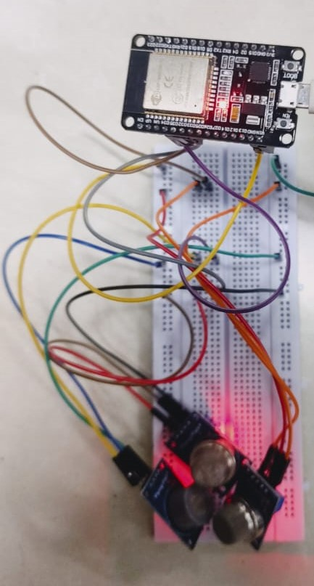

Figure 9 Prototype



Figure 10 Result of reading raw data MQ2 SENSOR with the help of prototype

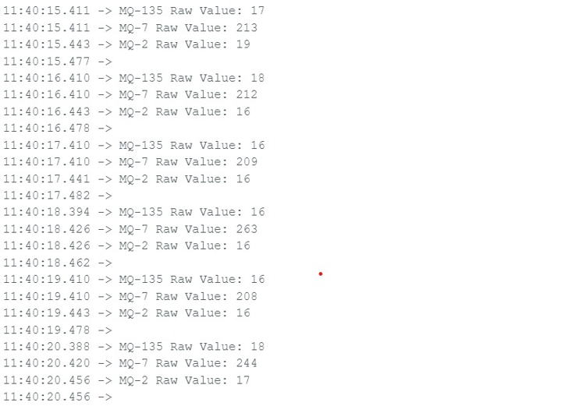

Figure 11 Result of reading raw data using multiple sensors in sequence of mq2, mq135, mq7 with the help of prototype

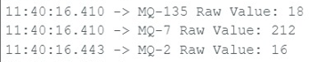

Figure 12 Result of reading raw data using multiple sensors in sequence of mq135, mq7, mq2 with the help of prototype

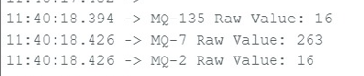

Figure 13 Result of reading raw data using multiple sensors in sequence of mq7, mq2, mq135 with the help of prototype

**

Figure 14 Result of reading raw data using multiple sensors in sequence of mq7, mq2, mq135 at certain distance

Discussion: Table 2 represents Comparison between Existing system and proposed system on the basis of Weight, Portability, reading forms and money value

Table 2 : Comparison between Existing System and Proposed System

|  |  |  |
| --- | --- | --- |
| Constraints | Existing System | Proposed System |
| Weight | Heavyweight | Lightweight |
| Portability | Not portable | Portable |
| Reading form | Static time value | Runtime values |
| Money Value | Expensive | Cheap |

1. **Conclusion**

Vehicle emissions play a major role in air pollution, which poses a substantial risk to both human and environmental health. Vehicle emissions may be tracked and managed using IoT-based technologies, which can also help to improve air quality. These systems can gather information on car emissions in run time, for the identification of high-emitting vehicles and the focused emission reduction plans. The effectiveness of emission control measures can be monitored using IOT-based systems, which can also give information for the creation of regulations. IoT-based vehicle emission monitoring and control systems can be expanded further and improved in a variety of areas. To further cut emissions and enhance air ‘transportation, such as public transit and traffic management systems. These systems could also be employed to create fresh and cutting-edge pollution control technologies. Systems for monitoring and regulating vehicle emissions that are IoT-based have the potential to significantly aid the effort to reduce air pollution. Air pollution is largely caused by vehicle emissions, which endanger both the environment and human health. Heart disease, lung conditions, and even early death are among the negative consequences of air pollution. IoT-based car emission monitoring and control systems have become a viable approach to address this urgent problem. IoT-enabled solutions provide a thorough, real-time method of managing and tracking vehicle emissions. These systems gather information on several pollutants, including hydrocarbons and carbon monoxide and carbon dioxide, using a network of sensors and communication devices mounted in cars. After that, the gathered data is sent to a central cloud platform for display and analysis. IoT-based emission monitoring systems provide insights that allow for numerous practical ways to lower air pollution. Classification of High-Emitting Vehicles: Through the examination of emission data, regulatory bodies are able to discern automobiles that persistently surpass emission regulations. To reduce their emissions, these cars can be the focus of additional care and inspection. Targeted Emission Reduction Plans: With the use of comprehensive emission data, policymakers are able to create plans that are specifically designed to reduce emissions from a given class of vehicle, fuel, and driving behavior. This strategy makes sure that the biggest sources of pollution receive the most of the attention when it comes to emission reduction. Keeping an eye on the efficacy of emission control measures IoT-based systems can continuously track the impact of emission control measures, such as fuel standards, emissions testing, and traffic.

Providing Information for Regulatory Policy Development: The information gathered from IoT systems' emissions can be very helpful in developing and improving emission standards. Policymakers can use this information to establish reasonable and attainable emission regulations for various car classes and fuel types. Connecting with Public Transportation and Traffic Management Systems: To encourage greener and more effective modes of transportation, IoT-based emission monitoring systems can be connected with public transit and traffic management systems. By promoting the use of public transit and improving traffic flow integration can aid in the reduction of overall car emissions

**References**

1. Kumaran, S., Arunachalam, S., Surendar, V., & Sudharsan, T. (2023, February). ”IoT-based Smoke Detection with Air Temperature and Air Humidity; High Accuracy with Machine Learning”. In 2023 Third International Conference on Artificial Intelligence and Smart Energy (ICAIS) (pp. 604-610),IEEE.
2. Kshirsagar, P. R, Manoharan, H, Al-Turjman, F & Maheshwari,K. K. (2020). ”Design and testing of automated smoke monitoring sensors in vehicles”. IEEE Sensors Journal, 22(18), 17497-17504.
3. Riegel, J, H. Neumann, and H-M. Wiedenmann. ”Exhaust gas sensors for automotive emission control.” Solid State Ionics 152 (2002): 783-800.
4. Bharathraj P, Arun Prasad V S, Aswin Kumar M, Shya- malaprasanna A, 2022, ”Vehicle Pollution Monitoring System using IoT, INTERNATIONAL JOURNAL OF ENGINEERING RESEARCH & TECHNOLOGY”, (IJERT) NCICCT – 2022 (Volume 10 – Issue 05).
5. ”Low-Cost CO Detector Integrated with IoT” was authored by Emmanuel Estrada, Miriam Moreno, Karina Mart´ın, A´ lvaro Lemmen Meyer, P.M. Rodrigo, and Sebastia´n Gutie´rrez. It was published by the Universidad Panamericana Aguascalientes in Mexico, IEEE Xplore on August 22, 2023.
6. R. Akhila, B. Amoghavarsha, B. Karthik, Y. Prajwal and Ba- jarangbali, ”Internet of Things based Detection and Analy- sis of Harmful Vehicular Emissions,” 2022 4th International Conference on Smart Systems and Inventive Technology (IC- SSIT), Tirunelveli, India, 2022, pp. 630-636, doi: 10.1109/IC- SSIT53264.2022.9716558..
7. D. Kandris, C. Nakas, D. Vomvas, and G. Koulouras, “Applications 591 of wireless sensor networks: An up-to-date survey,” Appl. Syst. Innov., 592 vol. 3, no. 1, pp. 1–24, Mar. 2020. 593
8. S. Ullo et al., “Application of wireless sensor networks to environmental 594 monitoring for sustainable mobility,” in Proc. IEEE Int. Conf. Environ. 595 Eng. (EE), Mar. 2018, pp. 1–7. 596.
9. S. Kaivonen and E. C.-H. Ngai, “Real-time air pollution monitoring with 597 sensors on city bus,” Digit. Commun. Netw., vol. 6, no. 1, pp. 23–30, 598 Feb. 2020. 599.
10. L. Andrea, R. Abirami, M. Diviya, and J. S. Nancy, “Framework for fire 605 detection and mitigation using IoT,” Int. J. Pure Appl. Math., vol. 118, 606 no. 18, pp. 1801–1811, 2018. 607
11. Q. Wu et al., “Intelligent smoke alarm system with wireless sensor 608 network using ZigBee,” Wireless Commun. Mobile Comput., vol. 2018, 609 no. 2, pp. 1–11, 2018. 610.
12. [K. Arjun, P. Prithviraj, and A. Ashwitha, “Sensor based application 611 for smart vehicles,” Int. J. Latest
13. R. Pi, “An IoI based forest fire detection using raspberry Pi,” Int. J. 614 Recent Technol. Eng., vol. 8, no. 4, pp. 9126–9132, 2019. 615.
14. F. Saeed, A. Paul, A. Rehman, W. Hong, and H. Seo, “IoT-based 618 intelligent modeling of smart home environment for fire prevention and 619 safety,” J. Sens. Actuator Netw., vol. 7, no. 1, p. 11, Mar. 2018. 620.
15. W. Li and W. Zhang, “Sensor selection for improving accuracy of target 621 localisation in wireless visual sensor networks,” IET Wireless Sensor 622 Syst., vol. 2, no. 4, pp. 293–301, Dec. 2012. 623.
16. A. Paul, A. Daniel, A. Ahmed, and S. Rho, “Cooperative cognitive 624 intelligence for Internet of vehicles,” IEEE Sensors J., vol. 11, no. 3, 625 pp. 1–10, 2017. 626.
17. K. D. Singh, P. Rawat, and J.-M. Bonnin, “Cognitive radio for vehicular 627 ad hoc networks (CR- VANETs): Approaches and challenges,” EURASIP 628 J. Wireless Commun. Netw., vol. 2014, no. 1,pp. 1–22, Dec. 2014. 629.
18. M. Younis and K. Akkaya, “Strategies and techniques for node place- 630 ment in wireless sensor
19. M. Maksimovi´c and V. Miloševi´c, “Evaluating the optimal sensor 633 placement for smoke detection,” Yugoslav J. Oper. Res., vol. 26, no. 1, 634 pp. 33–50, 2016. 635.
20. Status of the Vehicular Pollution Control Programme in India, Minist. 636 Environ. For. Govt. India, CPCB, New Delhi, India, 2010, pp. 1–114. 637.
21. R. Salazar-Cabrera, Á. P. de la Cruz, and J. M. M. Molina, “Sustainable 638 transit vehicle tracking service, using intelligent transportation system 639 services and emerging communication technologies: A review,” J. Traffic 640 Transp. Eng., vol. xxx, pp. 1–19, Nov. 2020. 641.
22. J. Wei, C.-H. Chiu, F. Huang, J. Zhang, and C. Cai, “A cost-effective 642 decentralized vehicle remote positioning and tracking system using 643 BeiDou navigation satellite system and mobile network,” EURASIP J. 644 Wireless Commun. Netw., vol. 2019, no. 1, p. 8, Dec. 2019. 645.
23. M. Bernas, B. Płaczek, W. Korski, P. Loska, J. Smyła, and P. Szymała, 646 “A survey and comparison of low-cost sensing technologies for road 647 traffic monitoring,” Sensors, vol. 18, no. 10, pp. 1–27, 2018. 648.
24. B. Misganaw and M. Vidyasagar, “Exploiting ordinal class structure in 653 multiclass classification: Application to ovarian cancer,” IEEE Life Sci. 654 Lett., vol. 1, no. 1, pp. 15–18, Jun. 2015. 655.
25. F. Al-Turjman and J. P. Lemayian, “Intelligence, security, and vehic- 656 ular sensor networks in Internet of Things (IoT)-enabled smart-cities: 657 An overview,” Comput. Electr. Eng., vol. 87, Oct. 2020, Art. no. 106776. 658.
26. S. Ramasubbareddy, S. Ramasamy, K. S. Sahoo, R. L. Kumar, 659 Q.-V. Pham, and N.-N. Dao, “CAVMS: Application-aware cloudlet 660 adaption and VM selection framework for multicloudlet envi- 661 ronment,” IEEE Syst. J., early access, Oct. 26, 2020, doi: 662 10.1109/JSYST.2020.30WW29807.